**CLASS:** F.Y. MCA  **SEM:** 2

**COURSE CODE:** MC509 **SUBJECT NAME:** Mobile Programming Lab

**UCID:** 2023510059 **BATCH:** C

**NAME:** Vivek Tiwari

**EXPERIMENT NO:** 01

**EXPERIMENT TITLE:** To create a Museum app using basic UI components and SASS [Syntactically awesome style-sheet]

**Tools used:**

Ionic framework paired with angular.

VS code

**Code:**

Tab1.page.html:

**<ion-header style="position: sticky;top: 0;">**

**<ion-toolbar style="display: flex;align-items: center;">**

**<ion-title style="margin-left: 10px; flex:2; padding-left: 60px;" > Kids </ion-title>**

**<ion-avatar slot="end">**

**<ion-img src="./assets/icon/boy.png" title="museum icons"></ion-img>**

**</ion-avatar>**

**</ion-toolbar>**

**</ion-header>**

**<ion-content [fullscreen]="true">**

**<ion-card *ngFor="let video of videos" (click)="playVideo(video.id)" class="cards">**

**<ion-card-header>**

**<ion-card-title>{{video.title}}</ion-card-title><br>**

**<img class="images"  src="{{video.src}}"/>**

**</ion-card-header>**

**<ion-card-content>**

**{{video.description}}**

**</ion-card-content>**

**</ion-card>**

**</ion-content>**

Tab1.page.ts:

**import { Component } from '@angular/core';**

**import { IonCardContent, IonHeader, IonToolbar, IonTitle, IonContent, IonImg, IonAvatar, IonCardTitle, IonCardHeader, IonCard, IonCardSubtitle} from '@ionic/angular/standalone';**

**import { ExploreContainerComponent } from '../explore-container/explore-container.component';**

**import { NavController } from '@ionic/angular/standalone';**

**import { NgForOf } from '@angular/common';**

**@Component({**

**selector: 'app-tab1',**

**templateUrl: 'tab1.page.html',**

**styleUrls: ['tab1.page.scss'],**

**standalone: true,**

**imports: [ NgForOf, IonHeader, IonToolbar, IonTitle, IonContent, ExploreContainerComponent, IonImg, IonAvatar, IonCardContent, IonCardTitle, IonCardHeader, IonCard, IonCardSubtitle],**

**})**

**export class Tab1Page {**

**constructor(private navCtrl: NavController) {}**

**playVideo(videoId: string) {**

*this***.navCtrl.navigateForward(`/videopage/${videoId}`);**

**}**

**videos =[**

**{id:'S83f3hT1BiQ', title:'The start of Indus Valley Civilization', src:'https://shorturl.at/gqvW8', description:'Come take a look at how one of the greatest Civilizations ever started.'},**

**{id:'KhDY4KJuvc0', title:'Facts about Indus Valley', src:'https://shorturl.at/mBC35', description:'Take a look at some facts about The Indus Valley.'},**

**{id:'oMXuzp3XcB8', title:'The Decline of Indus Valley Civilization', src:'https://shorturl.at/oJRW4', description:'Intriguied about what led to the decline of the greatest civiliazation? Lets check it out together'},**

**]**

**}**

Tab1.page.scss:

**ion-avatar{**

**height: 60px;**

**width: 70px;**

**padding-right: 1rem;**

**padding-top: 0.5rem;**

**padding-bottom: 0.3rem;**

**}**

**.cards{**

**border-radius: 30px 30px 30px 30px;**

**}**

**img{**

**border-radius: 30px 30px 30px 30px;**

**padding: 1px 1px 1px 1px;**

**}**

Tab2.page.html:

**<ion-content>**

**<ion-header style="position: sticky;top: 0;">**

**<ion-toolbar style="display: flex;align-items: center;">**

**<ion-title style="margin-left: 10px; flex:2; padding-left: 60px;" > Heritage of India </ion-title>**

**<ion-avatar slot="end">**

**<ion-img src="./assets/icon/museum1.png" title="museum icons"></ion-img>**

**</ion-avatar>**

**</ion-toolbar>**

**</ion-header>**

**<ion-card class="cards">**

**<img class="images" alt="Indus Valley" src="https://shorturl.at/ahnGW" />**

**<ion-card-header>**

**<ion-card-subtitle>3300 BCE - 1300 BCE</ion-card-subtitle>**

**<ion-card-title>Indus Valley Civilization</ion-card-title>**

**</ion-card-header>**

**<ion-card-content>**

**The Indus Valley Civilization, one of the earliest urban civilizations in present-day Pakistan and northwest India, showcased advancements in urban planning, sanitation, and craftsmanship.**

**Unveiling its mysteries through artifacts is akin to solving a captivating puzzle.**

**</ion-card-content>**

**</ion-card>**

**<ion-card class="cards">**

**<img class="images" alt="Seal" src="https://shorturl.at/blvyX" />**

**<ion-card-header>**

**<ion-card-subtitle>3300-1300 BCE</ion-card-subtitle>**

**<ion-card-title style="font-size:x-large;">Steatite Seal with Unicorn</ion-card-title>**

**</ion-card-header>**

**<ion-card-content>**

**<ul>**

**<li><b>Material:</b> Steatite (soapstone)</li>**

**<li><b>Dimensions:</b> Varies, typically around 3-5 cm in length and width, 1-2 cm thick</li>**

**<li><b>Origin:</b> Mohenjo-daro, Pakistan</li>**

**</ul>**

**</ion-card-content>**

**</ion-card>**

**<ion-card class="cards">**

**<img class="images" alt="Painted Pot" src="https://shorturl.at/gtxJW" />**

**<ion-card-header>**

**<ion-card-subtitle>3300 BCE - 1300 BCE</ion-card-subtitle>**

**<ion-card-title>Painted Pottery</ion-card-title>**

**</ion-card-header>**

**<ion-card-content>**

**<ul>**

**<li><b>Material:</b> Earthenware</li>**

**<li><b>Dimensions:</b> Varies, with pots ranging from a few centimeters to over 1 meter in height</li>**

**<li><b>Origin:</b> Various Indus Valley Civilization sites</li>**

**</ul>**

**</ion-card-content>**

**</ion-card>**

**<ion-card class="cards">**

**<img class="images" alt="Painted Pot" src="https://shorturl.at/eoKN9" />**

**<ion-card-header>**

**<ion-card-subtitle>3300 BCE - 1300 BCE</ion-card-subtitle>**

**<ion-card-title>Copper Tools</ion-card-title>**

**</ion-card-header>**

**<ion-card-content>**

**<ul>**

**<li><b>Material:</b> Copper</li>**

**<li><b>Origin:</b> <br>Mohenjo-daro, Pakistan.<br> Harappa, Pakistan <br>Rakhigarhi, India</li>**

**<li><b>Significance:</b> A wide variety of copper tools were found, including axes, chisels, knives, and saws.</li>**

**</ul>**

**</ion-card-content>**

**</ion-card>**

**</ion-content>**

Tab2.page.ts:

**import { Component } from '@angular/core';**

**import { IonCardTitle,IonCardSubtitle,IonCardHeader,IonCardContent, IonCard,IonHeader, IonToolbar, IonTitle, IonContent, IonAvatar,IonImg } from '@ionic/angular/standalone';**

**import { ExploreContainerComponent } from '../explore-container/explore-container.component';**

**import {  IonicModule } from '@ionic/angular';**

**@Component({**

**selector: 'app-tab2',**

**templateUrl: 'tab2.page.html',**

**styleUrls: ['tab2.page.scss'],**

**standalone: true,**

**imports: [IonCardTitle,IonCardSubtitle,IonCardHeader,IonCardContent, IonCard,IonHeader, IonToolbar, IonTitle, IonContent, ExploreContainerComponent, IonAvatar,IonImg]**

**})**

**export class Tab2Page {**

**constructor() {}**

**}**

Tab2.page.scss:

**ion-avatar{**

**height: 60px;**

**width: 70px;**

**padding-right: 1rem;**

**padding-top: 0.5rem;**

**padding-bottom: 0.3rem;**

**}**

**.images{**

**height: 300px;**

**width: 400px;**

**}**

**.cards{**

**border-radius: 30px 30px 30px 30px;**

**}**

Tab3.page.html:

**<ion-content [fullscreen]="true">**

**<ion-header style="position: sticky;top: 0;">**

**<ion-toolbar style="display: flex;align-items: center;">**

**<ion-title style="margin-left: 10px; flex:2; padding-left: 60px; font-size: x-large;" > Events </ion-title>**

**</ion-toolbar>**

**</ion-header><br>**

**<ion-datetime readonly></ion-datetime>**

**<ion-card *ngFor="let card of cards" class="cards">**

**<ion-card-header>**

**<ion-card-title>{{card.title}}</ion-card-title>**

**<br>**

**<ion-card-subtitle>{{card.subtitle}}</ion-card-subtitle>**

**</ion-card-header>**

**<img class="images" src="{{card.src}}"/>**

**<ion-card-content>**

**{{card.datetime}}**

**</ion-card-content>**

**</ion-card>**

**</ion-content>**

Tab3.page.ts:

**import { Component } from '@angular/core';**

**import { IonHeader, IonToolbar, IonTitle, IonContent,IonDatetime,IonDatetimeButton,IonCardContent, IonCardTitle, IonCardSubtitle, IonCardHeader, IonCard } from '@ionic/angular/standalone';**

**import { NgForOf } from '@angular/common';**

**@Component({**

**selector: 'app-tab3',**

**templateUrl: 'tab3.page.html',**

**styleUrls: ['tab3.page.scss'],**

**standalone: true,**

**imports: [NgForOf,IonHeader, IonToolbar, IonTitle, IonContent, IonDatetime,IonDatetimeButton, IonCardContent,IonCardTitle,IonCardSubtitle, IonCardHeader, IonCard],**

**})**

**export class Tab3Page {**

**constructor() {}**

**cards =**

**[**

**{title:'Pottery Painting Workshop', subtitle:'Price: Rs. 1000/-', datetime:'Date: 02-02-2024, Time: 14:00 - 16:00', src:'assets/paintingev.png'},**

**{title:'Ancient artifacts auction', subtitle:'Price: Free Entry', datetime:'Date: 05-02-2024, Time: 10:00 - 12:00', src:'assets/event2.jpeg'},**

**{title:'Understading the Indus Script', subtitle:'Price: Rs. 500/-', datetime:'Date: 15-02-2024, Time: 10:00 - 15:00', src:'assets/event3.jpeg'},**

**]**

**}**

Tab3.page.scss:

**ion-dateTime{**

**margin: 2rem 2rem;**

**}**

**.images{**

**height: 300px;**

**width: 400px;**

**padding: 1rem 1rem;**

**border-radius: 30px 30px 30px 30px;**

**}**

**.cards{**

**border-radius: 30px 30px 30px 30px;**

**}**

Tab4.page.html:

**<ion-content>**

**<ion-header style="position: sticky;top: 0;">**

**<ion-toolbar style="display: flex;align-items: center;">**

**<ion-title style="margin-left: 10px; flex:2; padding-left: 60px;" > Feedback </ion-title>**

**</ion-toolbar>**

**</ion-header>**

**<br>**

**<ion-list class="lists">**

**<ion-item>**

**<ion-card-title class="titles">Name:</ion-card-title>**

**<ion-input**

**placeholder="Please enter your name"**

**required**

**>**

**</ion-input>**

**</ion-item>**

**<div class="divider"></div>**

**<ion-item>**

**<ion-card-title class="titles">E-Mail:</ion-card-title>**

**<ion-input**

**placeholder="Please enter your E-Mail"**

**>**

**</ion-input>**

**</ion-item>**

**<div class="divider"></div>**

**<ion-item>**

**<ion-card-title class="titles">Contact:</ion-card-title>**

**<ion-input**

**placeholder="Please enter your Phone Number"**

**>**

**</ion-input>**

**</ion-item>**

**<div class="divider"></div>**

**</ion-list>**

**<div class="buttons">**

**<ion-button id="buttons" (click)="clearAllFields()">Clear All</ion-button>**

**<ion-button id="subbtn">Submit Feedback</ion-button>**

**</div>**

**<ion-alert**

**trigger="subbtn"**

**header="Your form has been submitted."**

**subHeader="Thank you for your feedback."**

**></ion-alert>**

**</ion-content>**

Tab4.page.ts:

**import { Component, ViewChildren, QueryList } from '@angular/core';**

**import { CommonModule } from '@angular/common';**

**import { FormsModule } from '@angular/forms';**

**import { IonInput,IonItem, IonLabel, IonList,**

**IonTitle, IonToolbar, IonHeader,**

**IonContent, IonItemDivider, IonProgressBar,**

**IonButton, IonCardTitle, IonCardSubtitle, IonAlert } from '@ionic/angular/standalone';**

**import { ReactiveFormsModule } from '@angular/forms';**

**@Component({**

**selector: 'app-tab4',**

**templateUrl: './tab4.page.html',**

**styleUrls: ['./tab4.page.scss'],**

**standalone: true,**

**imports: [ CommonModule, FormsModule, IonInput,**

**IonItem, IonLabel, IonList,**

**IonTitle, IonToolbar, IonHeader,**

**IonContent, IonItemDivider, IonProgressBar,**

**IonButton, IonCardSubtitle, IonCardTitle, IonAlert, ReactiveFormsModule**

**]**

**})**

**export class Tab4Page {**

**@ViewChildren(IonInput) inputFields!: QueryList<IonInput>;**

**public progress = 0;**

**constructor() {**

**setInterval(() => {**

*this***.progress += 0.1;**

**}, 90);**

**}**

**clearAllFields() {**

*this***.inputFields.forEach((inputField) => {**

**inputField.value = '';**

**});**

**}**

**}**

Tab4.page.scss:

**.divider{**

**height: 1px;**

**background-color: #ccc;**

**margin: 10px 0;**

**}**

**.lists{**

**border-radius: 30px 30px 30px 30px;**

**margin: 1rem 1rem 1rem 1rem;**

**height: fit-content;**

**}**

**.titles{**

**padding: 1rem 1rem 1rem 0rem;**

**}**

**.buttons{**

**margin: 10px;**

**padding: 10px;**

**text-align: center;**

**}**

Tabs.page.html:

**<ion-tabs>**

**<ion-tab-bar slot="bottom">**

**<ion-tab-button tab="tab1" href="/tabs/tab1">**

**<ion-icon aria-hidden="true" name="brush"></ion-icon>**

**</ion-tab-button>**

**<ion-tab-button tab="tab2" href="/tabs/tab2">**

**<ion-icon aria-hidden="true" name="home"></ion-icon>**

**</ion-tab-button>**

**<ion-tab-button tab="tab3" href="/tabs/tab3">**

**<ion-icon aria-hidden="true" name="calendar-Number"></ion-icon>**

**</ion-tab-button>**

**<ion-tab-button tab="tab4" href="/tabs/tab4">**

**<ion-icon aria-hidden="true" name="chatbox"></ion-icon>**

**</ion-tab-button>**

**</ion-tab-bar>**

**</ion-tabs>**

Tabs.page.ts:

**ion-tab-button{**

**padding-left: 1rem;**

**padding-right: 1rem;**

**padding-bottom: 0.75rem;**

**padding-top: 0.75rem;**

**size: 80px;**

**}**

Tabs.page.scss:

**import { Component, EnvironmentInjector, inject } from '@angular/core';**

**import { IonTabs, IonTabBar, IonTabButton, IonIcon, IonLabel } from '@ionic/angular/standalone';**

**import { addIcons } from 'ionicons';**

**import { triangle, ellipse, square, home, brush, calendarNumber, chatbox } from 'ionicons/icons';**

**@Component({**

**selector: 'app-tabs',**

**templateUrl: 'tabs.page.html',**

**styleUrls: ['tabs.page.scss'],**

**standalone: true,**

**imports: [IonTabs, IonTabBar, IonTabButton, IonIcon, IonLabel],**

**})**

**export class TabsPage {**

**public environmentInjector = inject(EnvironmentInjector);**

**constructor() {**

**addIcons({ triangle, ellipse, square,home, brush, calendarNumber, chatbox });**

**}**

**}**

videopage.page.html:

**<ion-header style="height: 80px;">**

**<ion-toolbar>**

**<ion-buttons slot="start" >**

**<ion-back-button defaultHref="/tabs/tab1"></ion-back-button>**

**</ion-buttons>**

**<ion-title>**

**Video Page**

**</ion-title>**

**</ion-toolbar>**

**</ion-header>**

**<ion-content>**

**<div *ngIf="videoId">**

**<iframe width="100%" height="400px" [src]="getSafeVideoUrl(videoId)" frameborder="0" allowfullscreen></iframe>**

**</div>**

**</ion-content>**

videopage.page.ts:

**import { Component } from '@angular/core';**

**import {  IonContent, IonTitle, IonBackButton, IonButtons, IonToolbar, IonHeader } from '@ionic/angular/standalone';**

**import { ActivatedRoute } from '@angular/router';**

**import { CommonModule } from '@angular/common';**

**import { DomSanitizer, SafeResourceUrl } from '@angular/platform-browser';**

**@Component({**

**selector: 'app-videopage',**

**templateUrl: './videopage.page.html',**

**styleUrls: ['./videopage.page.scss'],**

**standalone: true,**

**imports: [ IonContent, IonTitle, IonBackButton, IonButtons, IonToolbar, IonHeader, CommonModule]**

**})**

**export class VideopagePage {**

**videoId!: string;**

**constructor(private route: ActivatedRoute, private sanitizer: DomSanitizer) {**

*this***.route.params.subscribe(params => {**

*this***.videoId = params['id'];**

**console.log('Video ID:',** *this***.videoId);**

**});**

**}**

**getSafeVideoUrl(videoId: string): SafeResourceUrl {**

**const videoUrl = `https://www.youtube.com/embed/${videoId}`;**

**console.log('Safe Video URL:', videoUrl);**

**return** *this***.sanitizer.bypassSecurityTrustResourceUrl(videoUrl);**

**}**

**}**

**Output:**

**Home Page:**

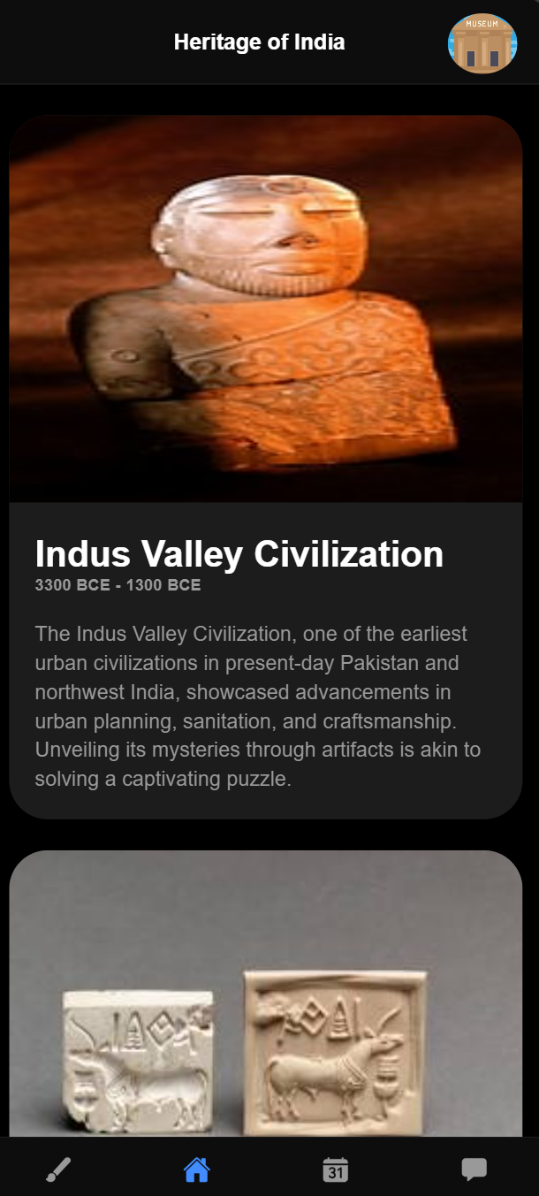 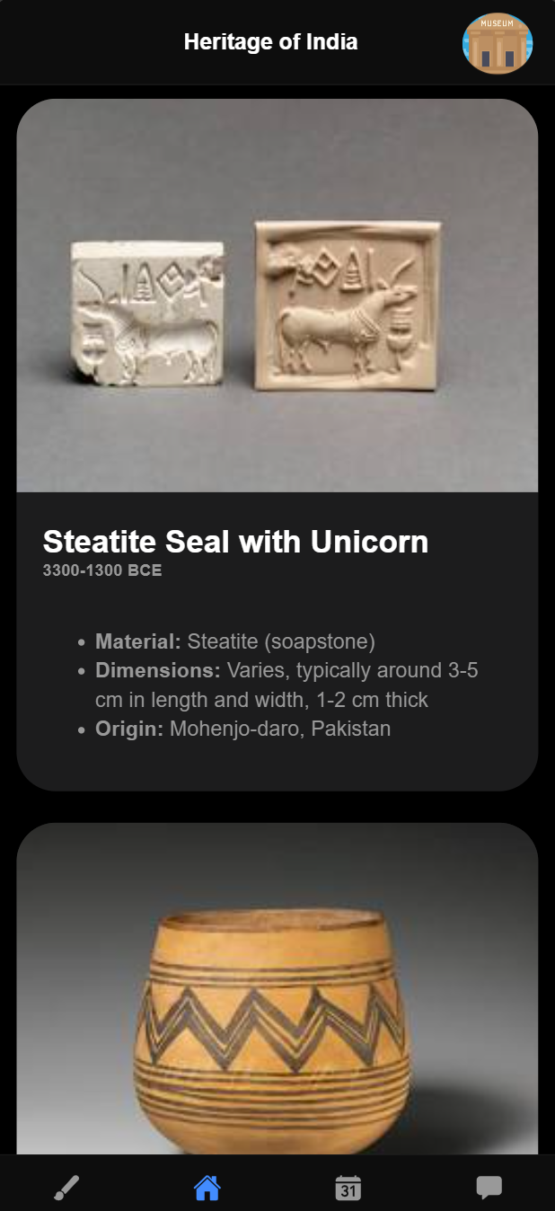 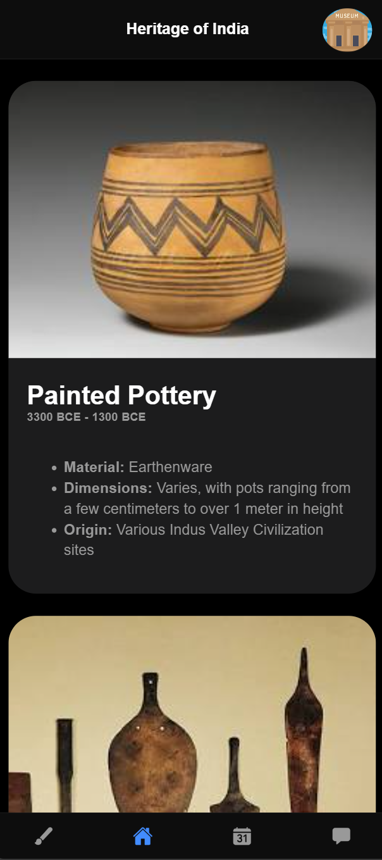

**Kids Sections:**

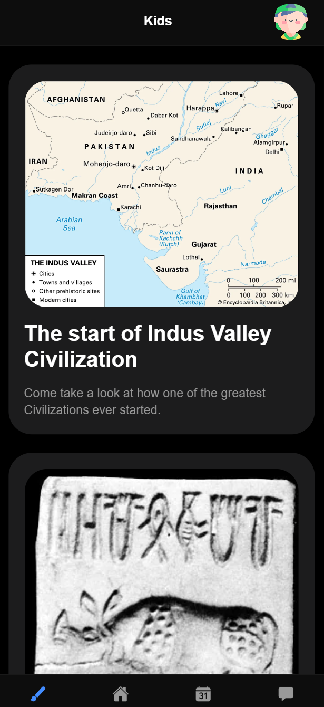 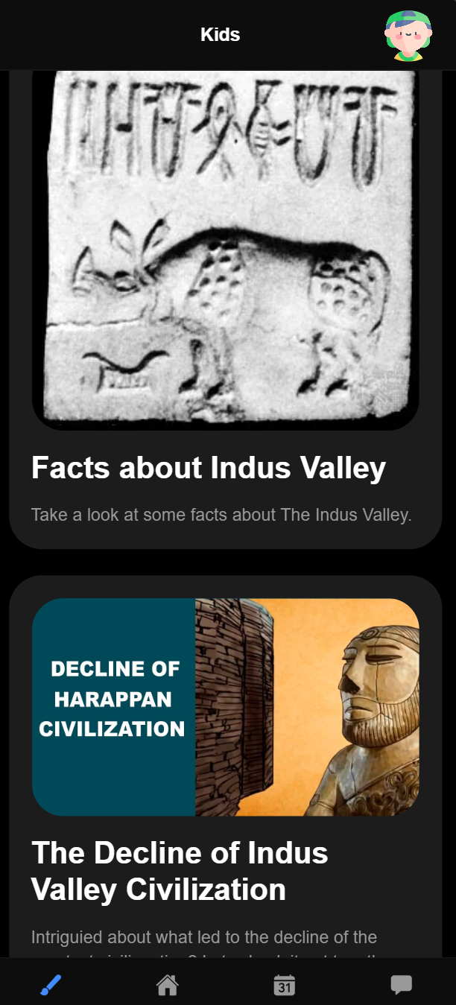 

**Events Tab:**

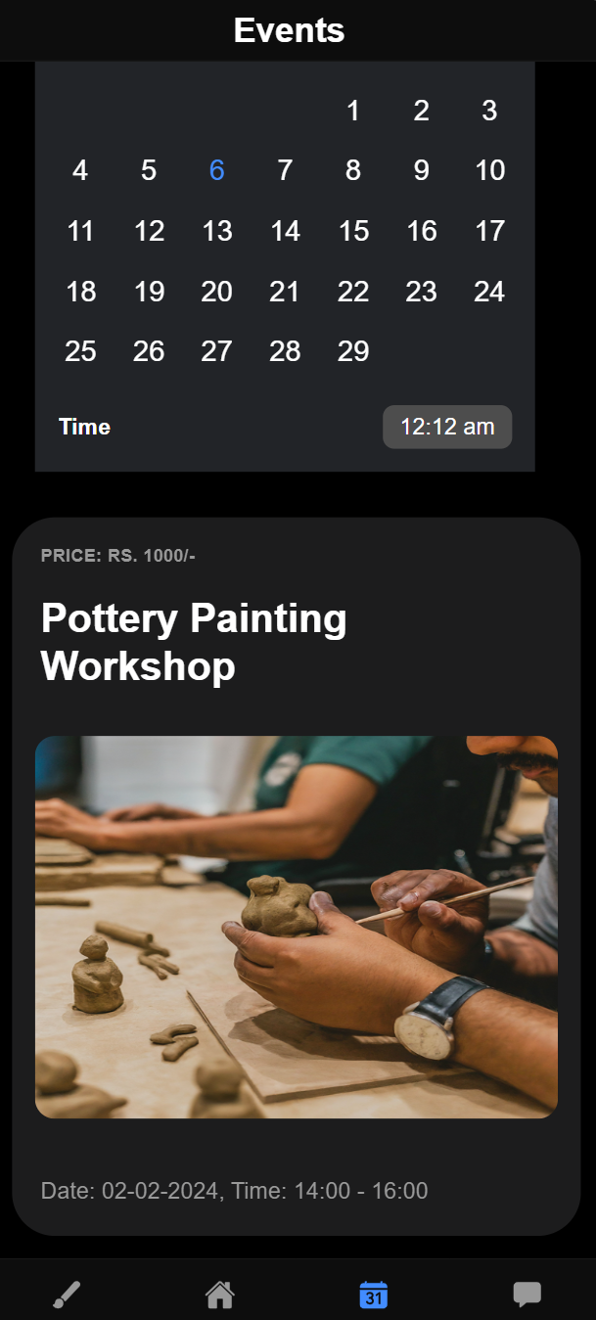 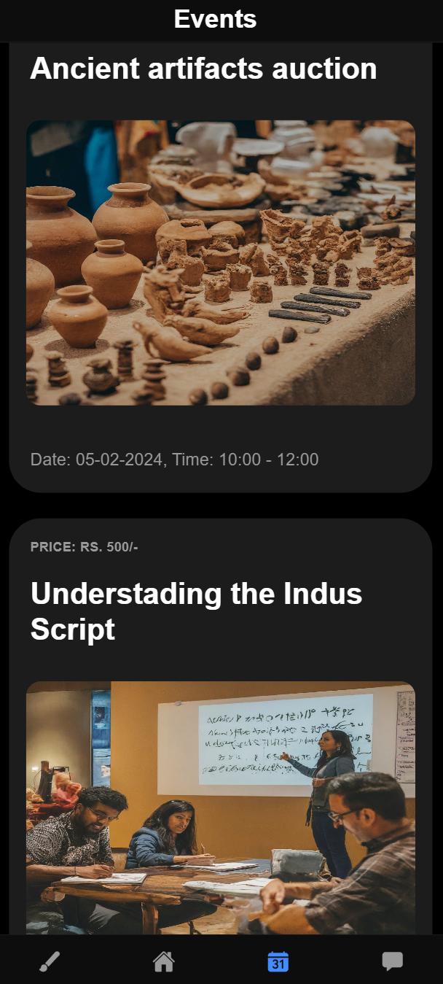

**Forms & Alert tab:**

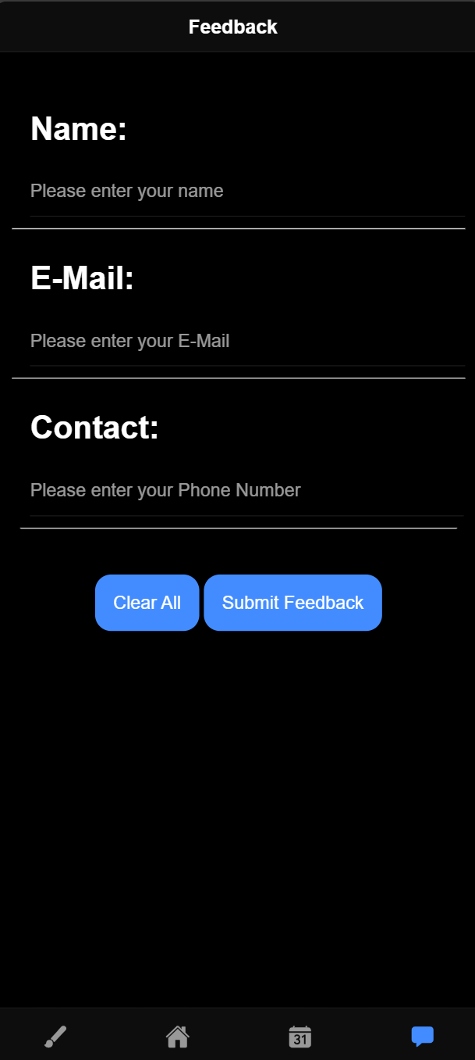 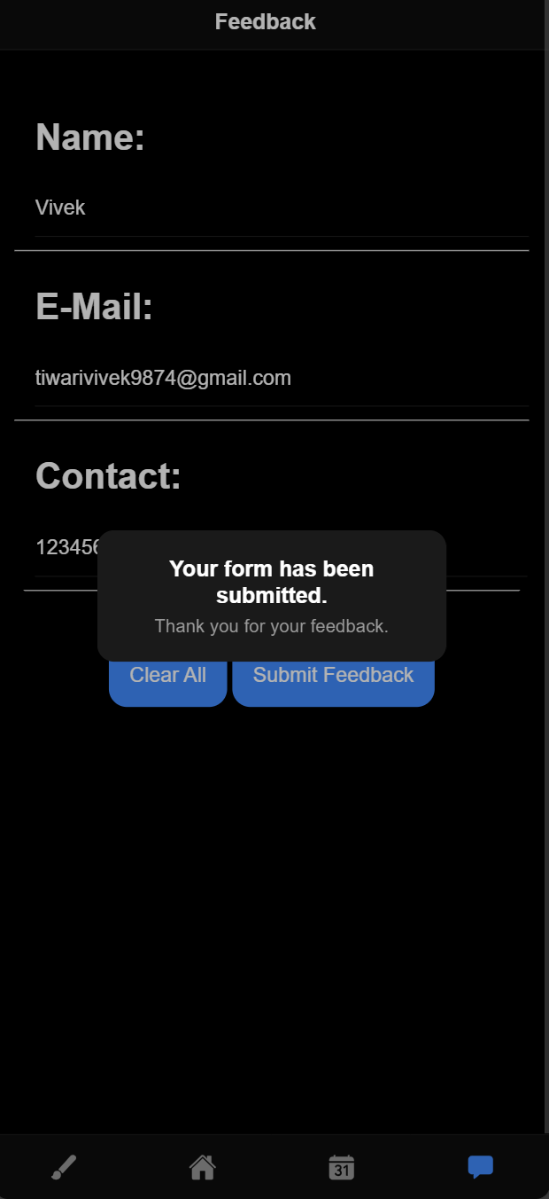

**Q&A:**

**Q.1 What are the features of SASS?**

- Variables: Store values for reuse, such as colors or sizes.

- Nesting: Nest selectors to reduce redundancy and establish hierarchy.

- Mixins: Create reusable style components with the `@mixin` and include them with `@include`.

- Operators: Perform arithmetic operations on numbers, colors, or units.

- Modules: Organize styles into separate files and import them with `@use` or `@import`.

**Q.2 Explain @mixin, @include, @extend, @import in SASS.**

- @mixin: Defines a reusable set of styles.

- @include: Incorporates a mixin into a rule.

- @extend: Extends styles of another selector.

- @import: Imports styles from another file.

**Q.2 What is the use of routerLink?**

- The `routerLink` directive in Angular enables declarative navigation between routes, enhancing user experience by allowing seamless navigation between different sections of the application.

**Q.3 What is the difference between component and page?**

- In Angular, a component and a page are essentially the same, representing a reusable unit of UI. In Ionic, a component is a reusable UI element, while a page is a specific type of component serving as a view or screen.

**Q.4 List ways to route between pages.**

- RouterLink: Create links to specific routes.

- Router.navigate and Router.navigateByUrl: Programmatic navigation within component classes.

- NavController: Service for navigation in Ionic applications.

**Q.5 Explain @NgModule properties in Angular.**

- declaration: Components, directives, and pipes specific to the module.

- import: Modules whose exported components, directives, and pipes are required.

- bootstrap: Designates the root component for bootstrapping the application.

- export: Components, directives, and pipes visible to other importing modules.

**Q.6 How do we add a component to a specific page?**

1. Create the component using `ionic generate component`.

2. Import the component in the page module.

3. Declare the component in the module's `declarations` array.

4. Use the component selector in the page template.